**4COM2006, Team Software Project**

**Final Report**

**Project Title: HertZone**

**Student ID: 20034089**

1. **Reconfirmation of Project Aims**

In this report, I would be summarising all the key events that took place during the latter half of the team software project. Collectively we had all decided that we should keep to the University Crisis Management System Project. We decided to stay with this because we had done hours of research into thinking of ways, we could make the website for the University Crisis management more interactive. We had made a slight change to the ending of the previous aim which had said we intended “to help students that are unable to attend classes by giving them work material”. In the new section of the aim, we had said: “to help students upload their work”. This change was made because it would not be feasible to provide work to students across the university who studied different courses that we had no knowledge in; hence we could not provide them with work. So, our new aim was “to create a functional university platform for Hertfordshire university, which updated students when in a crisis such as virus outbreaks, severe weather conditions, and to help students upload their work”. The objectives were:

* The platform should stand out in a user-friendly way so that it is easy to use for all students
* It should be compatible with all devices
* There should be concise/relevant services on the platform for students
* The chatbot should be able to reply to simple questions inputted from the user
* The chatbot should work without any issues within the website.

My main role within the group was to develop the chatbot. This meant I had to use the research that my colleagues had conducted to then create an interactive chatbot that would provide information and answer questions that the user had.

***Table 1 (figure 1)***

|  |  |  |  |
| --- | --- | --- | --- |
| Member/roles | Tasks for week 1 | Tasks for week 2 | Tasks for week 3 |
| Alex – Team Leader/ Website creator | Find images for website | Start designing website | Refine website and add the chatbot to website |
| Mary – Lead researcher/ Writing agendas | Research on information that would go on website and try out prototype apps for phone web | Use the Justinmind app to make a prototype | Refine phone app prototype |
| Adon – Project Planner/ Researcher for the chatbot (Herts bot) | Create a Gantt chart for the weeks ahead | Develop the chatbot | Fix up any further errors with the chatbot |
| Anup – Co-Researcher | Research about apps | Create phone app prototype | Refine phone app prototype |

1. **Background review**

From the last report, I learned that a chatbot is a piece of artificial intelligence software that can mimic a discussion with a user in natural language via messaging apps. They provide a 24/7 support system without the help of human assistance.

My initial plan was to use the chatbot system provided by oracle because there were some useful videos on YouTube on how to create a chatbot. However, after more research, I had come to find out that we would need to pay an extreme monthly subscription fee that my colleagues and I were not willing to pay. I was not an expert at coding so I needed to find an app/website that I could use to create our chatbot. During my research, I found many chatbot applications. I would list a few of them in my references. Most of the chatbots had many downsides such as high pricing, limited functions or it was just the case of me not liking the software interface. After trialing out many applications I decided to choose a chatbot builder called landbot. The interface was the feature that made me admire the platform the most as it was simple for a beginner like me to use. The chatbot creator mainly relied on me linking entities and using variables and for this I found myself using skills from the Data modelling.

Before creating my chatbot I decided to conduct vignette research into the different types of chatbots and the theory behind them. Mugan (2017) notes that there are three classes of chatbots. These being a purposeless mimicry agent, intention-based agents and controversial agents. Intention-based agents such as Amazon’s Alexa would have been way too complex to build and it would not have been needed for our simple FAQs type of chatbot that we required. The controversial agents would have been too sophisticated for our first-year group project and once more it was not a suitable candidate as a Chatbot. Therefore, I made the decision to create a purposeless mimicry agent as this was easier to create and would not be as complex as the others despite providing the user with a real conversation. This type of chatbot works by being trained with a range of dialogs and then learn to create the next statement depending on the previous statement (Mugan, 2017). After further investigation into Chatbot Interaction, I came across that “the level of friendliness, expertise and tone-awareness of the chatbot do contribute to the user-satisfaction” (Hendriks, Ou, Amiri, & Bockting, 2020). Therefore, as the chatbot designer it was important I had designed the chatbot in a way that would satisfy my target audience and leave them reassured after they had experienced using the chatbot.

1. **Methodology**

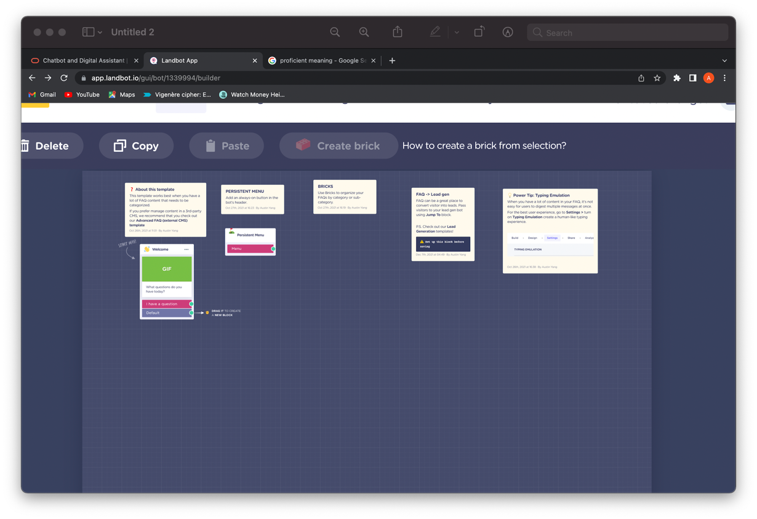The project was managed through trello as it had worked perfectly for our team for the interim and we provided each other with constant updates to our own tasks so everyone was always aware of what had been completed. I began by adopting a trial-and-error technique where I would go and experiment using different websites that provided a chatbot creator. Whilst I was using the website, I had an abstract criteria

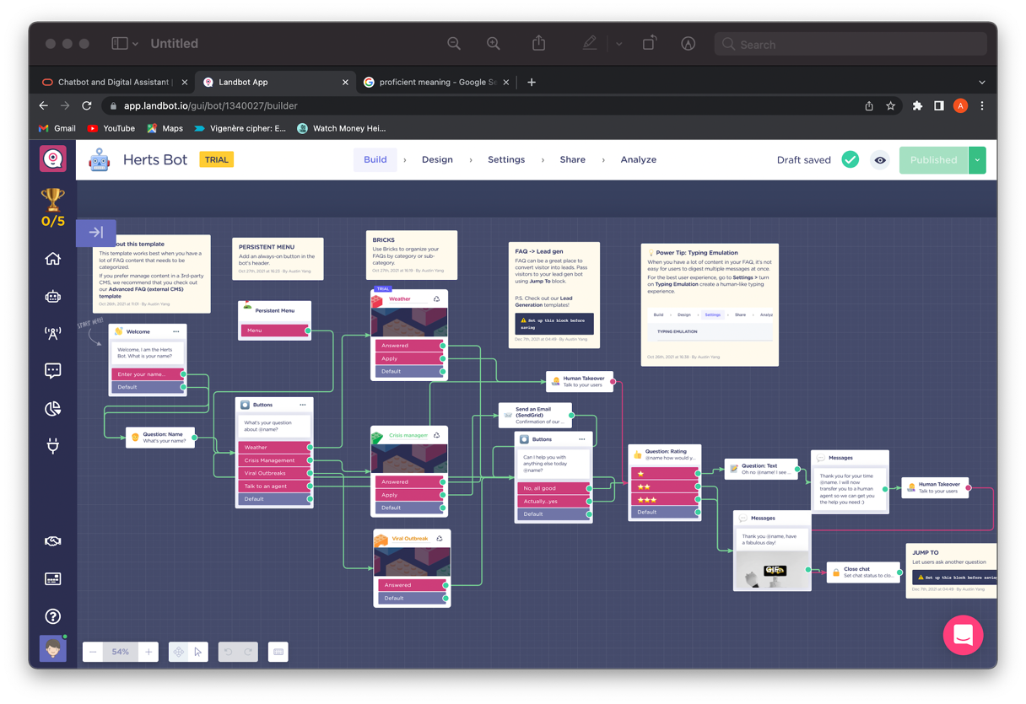these were: the website should be straightforward to use, it should have special features, pricing should be relatively cheap, and I should have been able to share it as a HTML code so it can be used on our website made by HTML. The names of some of the chatbots I experimented with are oracle digit assistant, Chatbot creator and Bot penguin. I have provided a link to all the websites I used in the appendix. However, the website I enjoyed using the most was called Landbot. This software mainly relied on an intuitive drag and drop interface for the conversations. Again, as mentioned before I was proficient at this as I used my skills from Data modelling by linking entities together and joining the primary and foreign keys to the correct places. The interface in figure 2 at first was empty as I had not yet put the entities in. After I had placed all the entities and linked all the relationships to the entities it looked complete (figure 3). Each entity that I created had more questions and information for the user in it and all this again had to be linked to the correct entities. In figure 4 you can see the weather entity in detail.

Figure 3

Figure 2

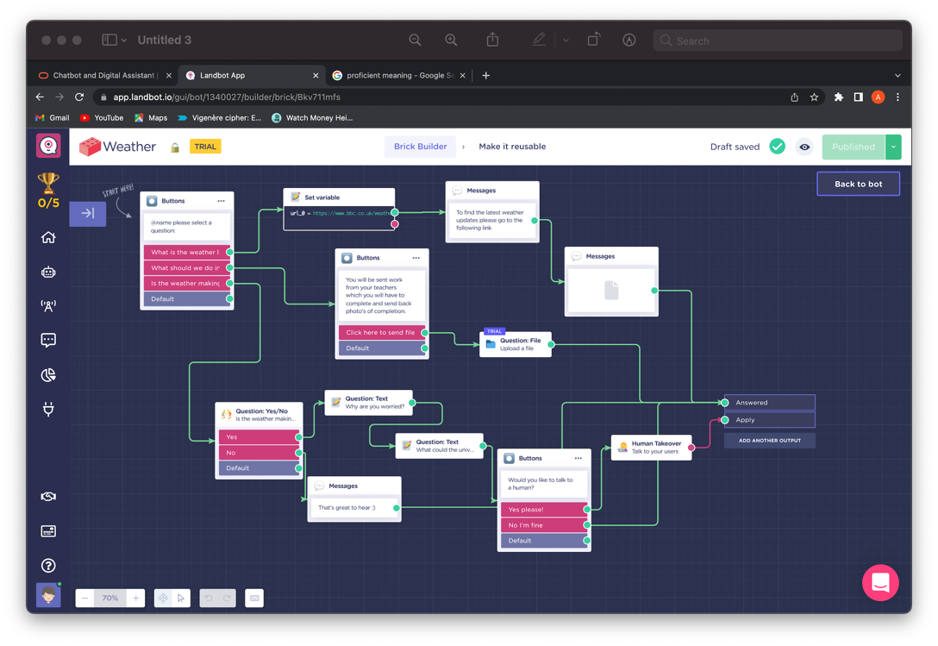

Figure 4

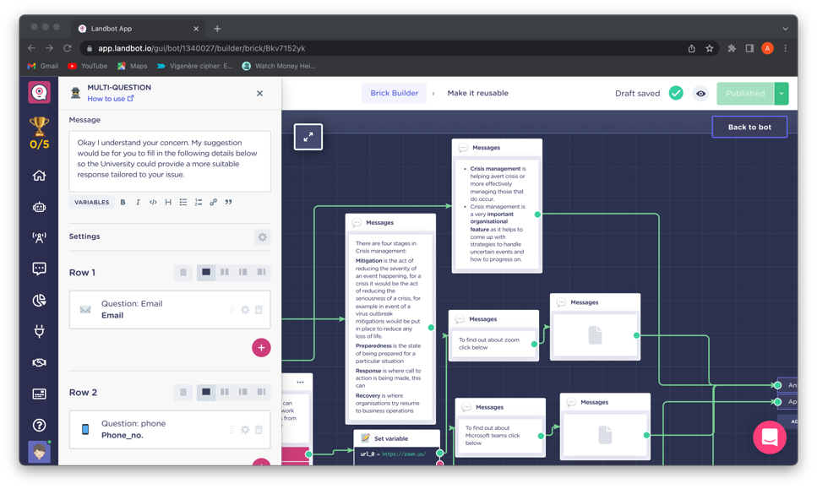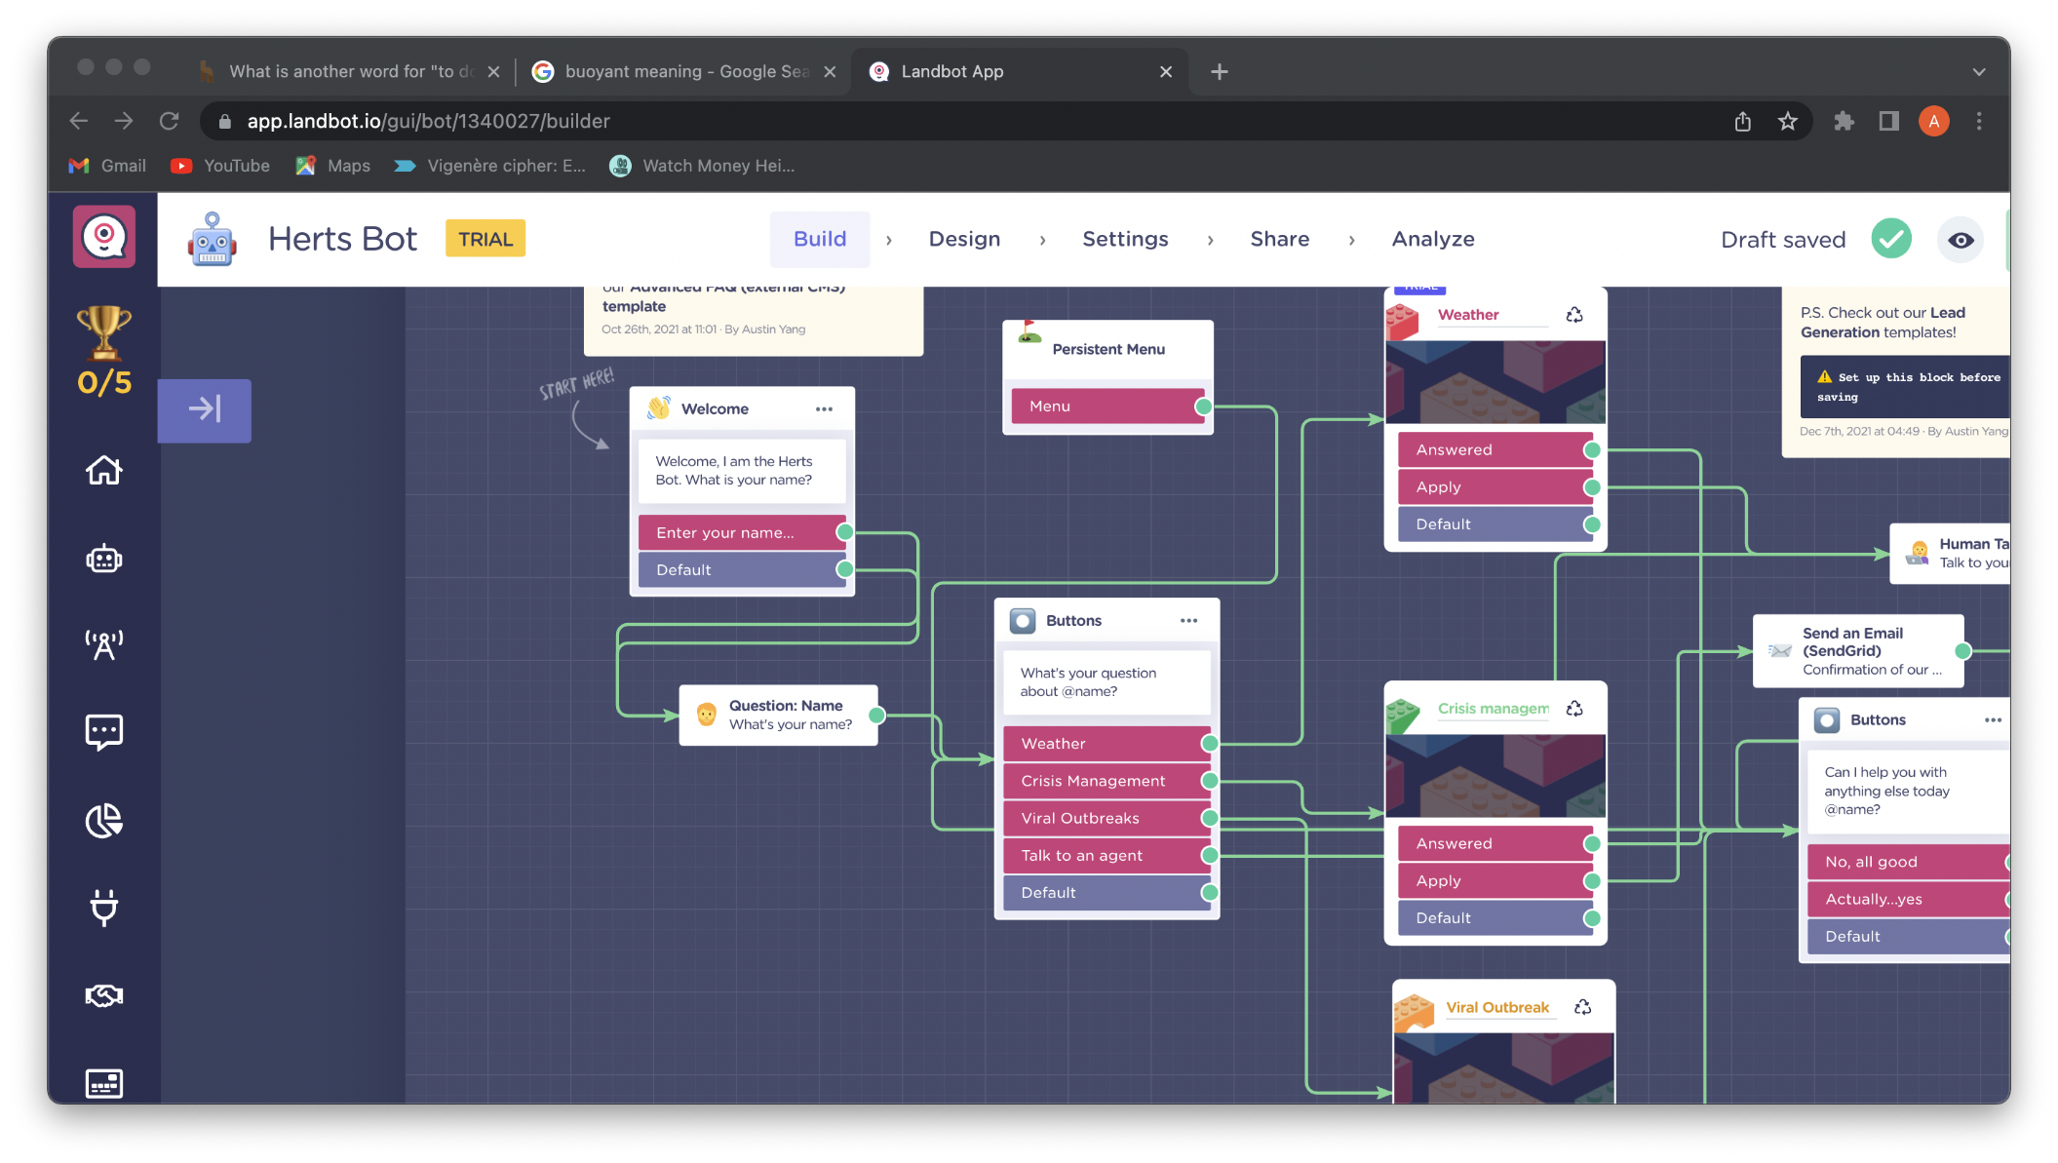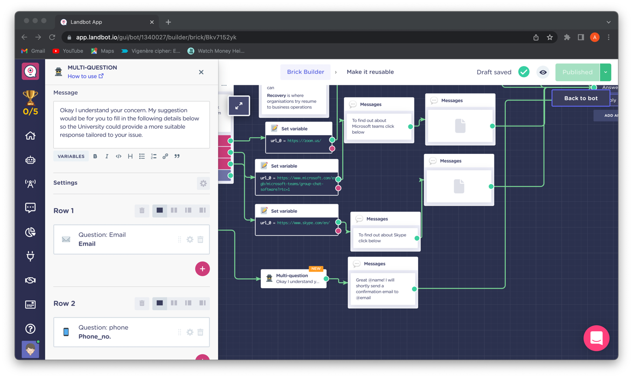I chose to use the purple colour scheme that had represented Hertfordshire University and I wanted it to go alongside the colour scheme of the website and the logo we had designed for HertZone. When I wrote the responses for the chatbot I needed to implement a buoyant tone as my target audience was aimed at young people that went to the university. Also, the university being a stressful environment for most young people I had to make sure the chatbot appeared to be as cheerful as possible. I achieved this by addressing the individual’s name in each conversation that they had with the chatbot. This gave the illusion to the individual that the chatbot was talking to them. To do this I had to capture the individual’s name as a variable and then use the variable later during the conversation. Figure 5 is an example of how I took the user’s name and then used it, later on, to address them in the conversation. Here you can see that the variable “@name” stores the user’s name. Within the chatbot, there is a section where students can address any of their concerns regarding crisis management to the university through the chatbot. But this requires the students to provide their email and phone number (figure 6) so that one of the staff from the university can contact them to discuss their issue. Personally, this was a great way for students to get a direct response to their concerns. Before adding this function into the chatbot I had to take note of all legal considerations regarding GDPR as this involves students’ personal data. However, since this chatbot is being created for Hertfordshire university all students using this will ultimately have agreed for their data to be used for the university to contact them. As for the data protection act, all data will be of the university’s concern therefore it is up to the university how they will use the data accordingly per individual. Another social group I took into consideration was people with visual impairments. The chatbot I designed caters to them as I have used bold fonts to highlight important individual parts and the text style I used is very defiant (figure 7). Perhaps a further improvement I could make if I was given more time is to add a voice accessibility feature to the chatbot to assist students with hearing difficulties.

Figure 7

Figure 6

Figure 5

1. **Implementation**

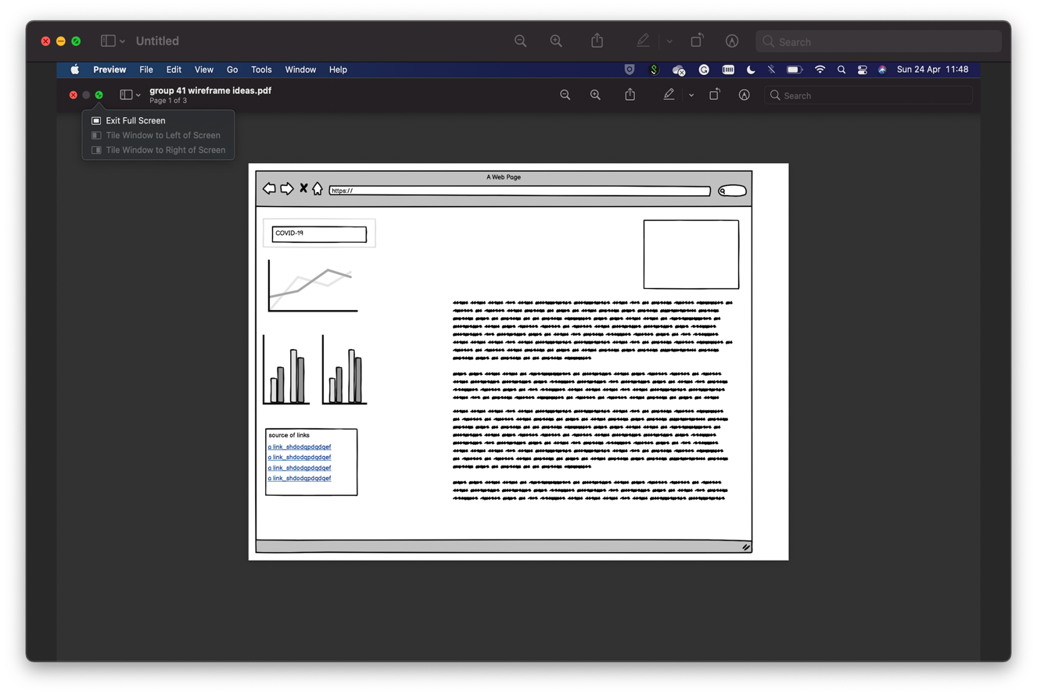During the interim, our project just consisted of mind maps which we then turned into wireframes. The use of wireframes was important because it gave us an overview of how where certain text, images and tabs would be placed when we had come to creating the website. (Figure 8 and 9 are screenshots of the wireframes).

Figure 8

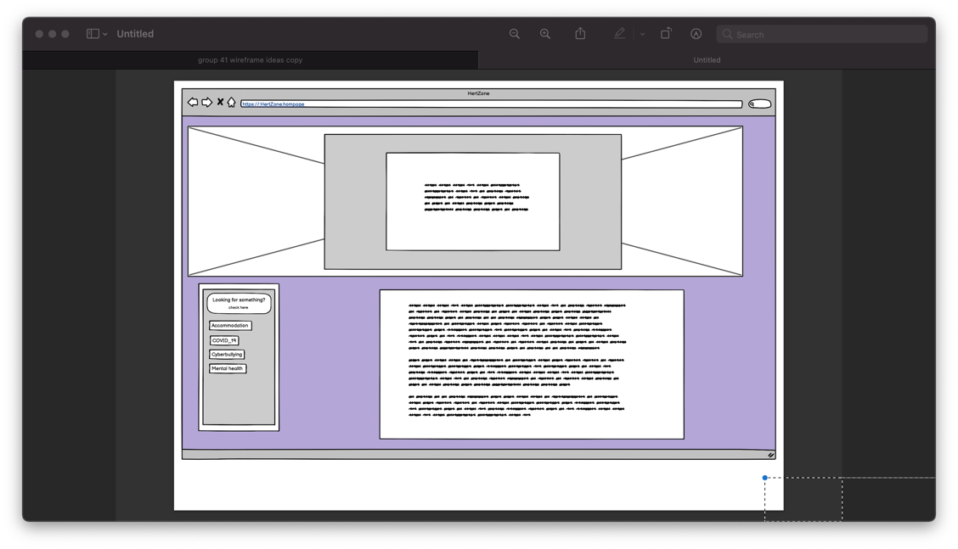

Figure 9

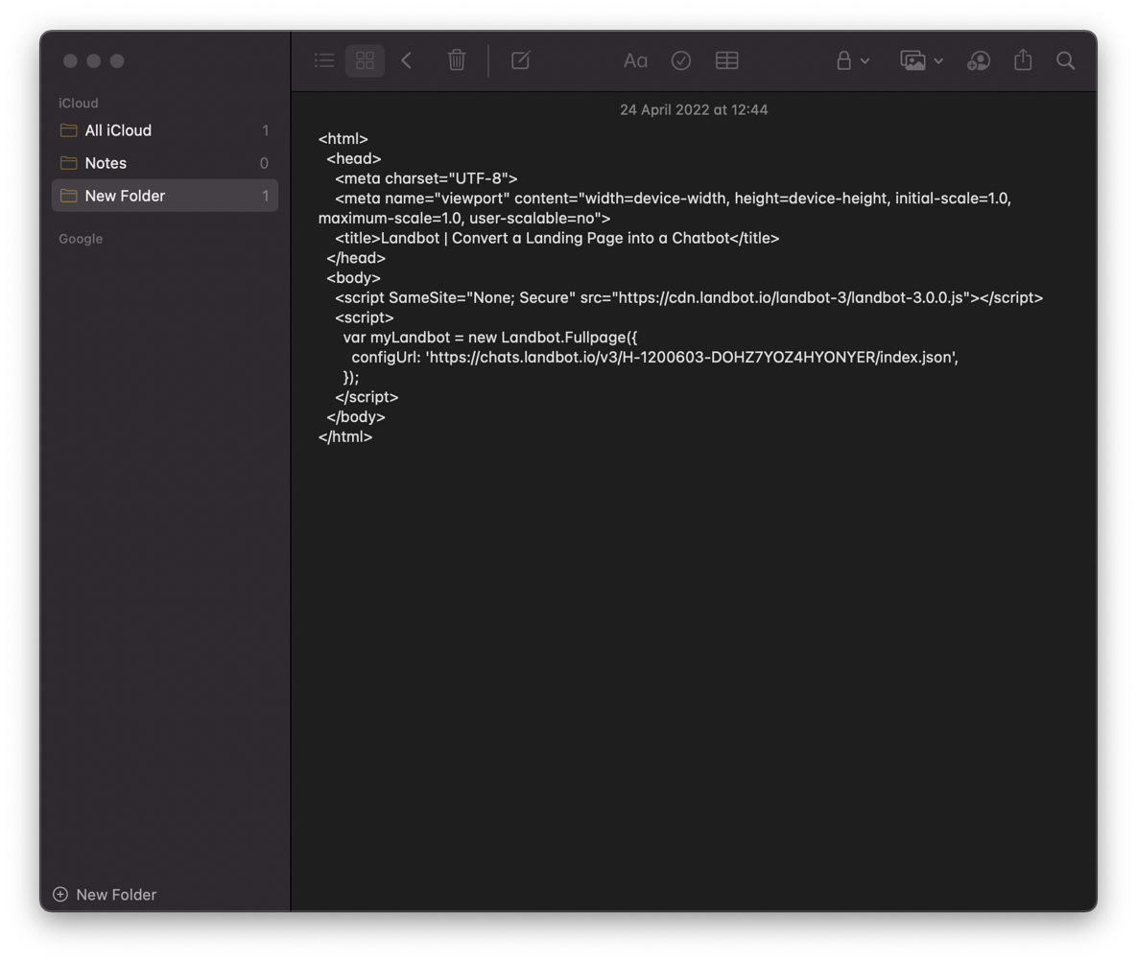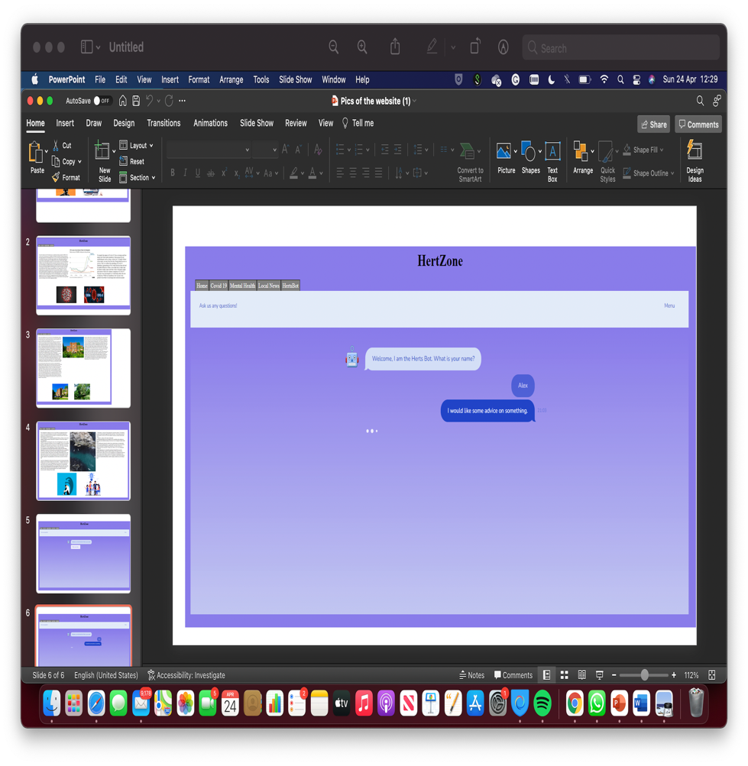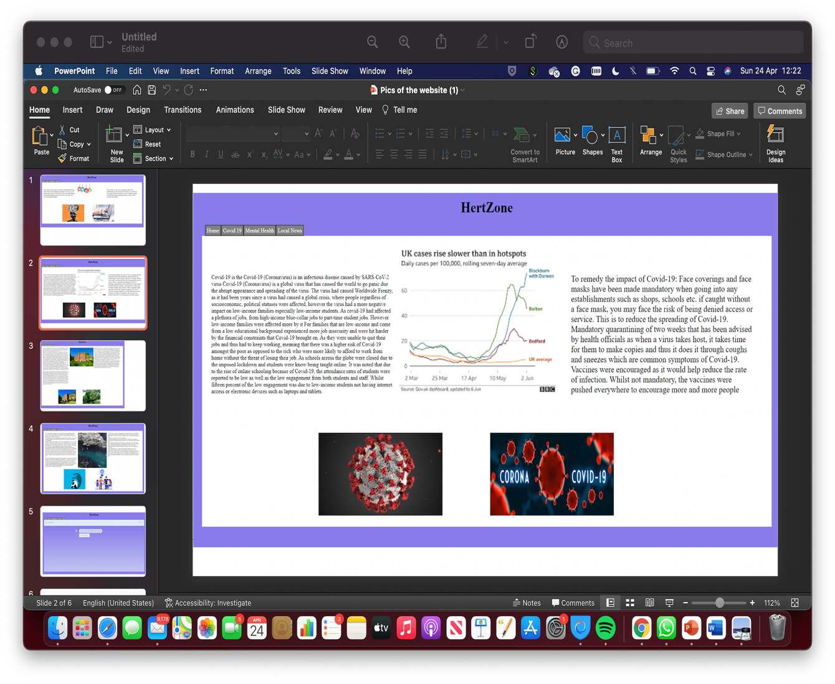Mary and Anup oversaw all the research which we would later use on our website as the information (text) on our website (Figure 10). Alex created the whole website using his skills using HTML and he used Mary's mood board (appendix) to gather pictures that were to be used on the website. On the website, there were different tabs the user could click to find out more information. Our website also contained graphs that backed up the information we were trying to get across to our students. Figure 11 shows how the Herts Bot (chatbot) I created looked on the website. Without the Herts Bot, we would not have been able to make the website more interactive and this was one of our objectives which we achieved through the incorporation of the chatbot function. We had combined the website and chatbot together as I gave Alex the HTML code for the chatbot (figure 12) which he then used on his main script of HTML code for the website. Mary had also created a website like the one Alex had created but the website she created was compatible with mobile phones (figure 13). Therefore, we were successful in achieving our objective of the final artefact being compatible with all devices.

Figure 12

Figure 11

Figure 10

1. 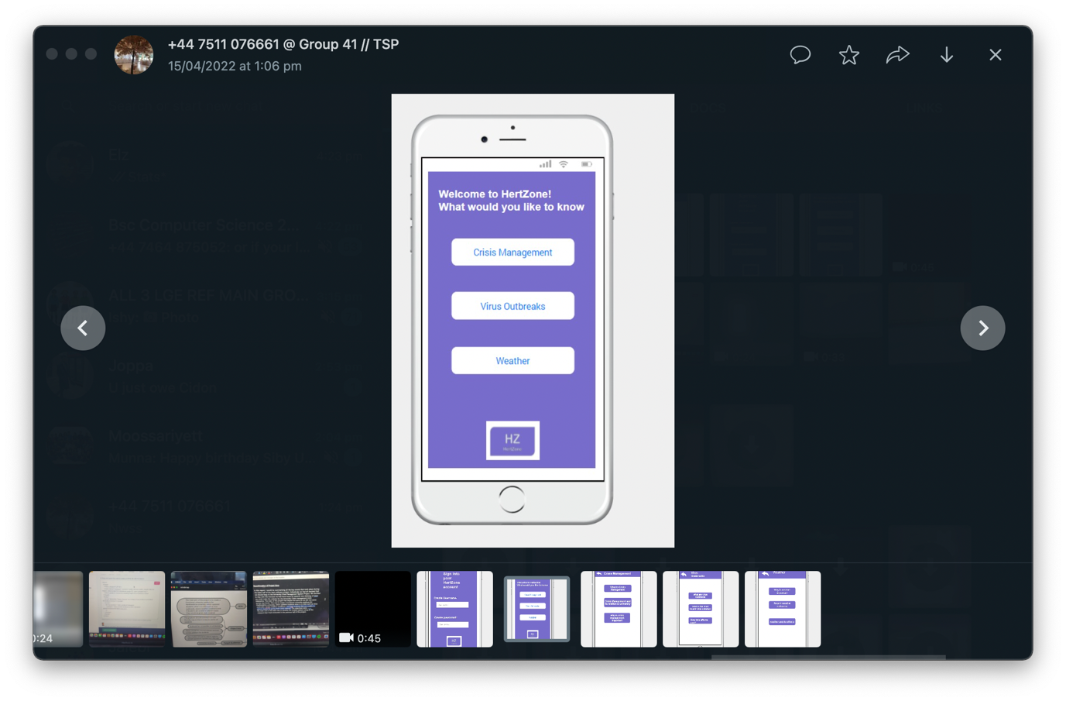**Evaluation**

After reviewing our objectives from section 1 it is justifiable to conclude that we have met all our objectives. The platform is user-friendly as everything on there is self-explanatory. The user has three tabs to choose from which is Crisis Management, Virus outbreaks, or weather. We have allowed the website to be compatible with all devices by creating a separate website for digital mobiles. As far as the criteria for the chatbot it works efficiently giving appropriate responses to the user's questions and it works within the website too whilst being interactive. The chatbot I created contributes to the overall website by making it more interactive so users can get the information they require much quicker than without the chatbot function. The chatbot function also allows you to talk to a human agent and I feel like this function is amazing for university students who at most times are very anxious and there isn’t much help available for them. For anxious students, they can use this chatbot function, so they get the appropriate help they need. If I was to recreate this chatbot I would have created it having my colleagues sitting next to me so they can provide me with more information and ideas that could possibly make the chatbot better than it already is.

Figure 13

1. Conclusions

To conclude I have learnt through creating the chatbot that I need to be able to think what the user’s needs and questions might be. I have also learnt that it is through the process of trial and error that you are only going to get the best possible version of a chatbot, and it is not something that cannot be rushed in a few days. From my research about websites, I have learnt that too much text on a website is usually an eye sore to the user and only important things need to be mentioned to the user in order for them to enjoy your website. From my experience of working with others I have learnt that it is highly important to have a mixed range of online and in-person meetings to better get across your points and to see how each colleague's work is going to fit with your work. In all honesty as a group, we did not conduct many in-person meetings. Consequently, this led to one person in our team having only access to the main website and the rest of us could not have access to the final product. This colleague was not able to come back to the university to send the website link to the rest of the team therefore we were only left with screenshots of the website. Therefore, next time I would ask that everyone has a link to everyone else's individual work so if something is to happen we all have access to our work.

**Referencing**

Mugan, J 2017, *Chatbots: Theory and Practice*, Intuition Machine, viewed 27 March 2022, <<https://medium.com/intuitionmachine/chatbots-theory-and-practice-3274f7e6d648>>.

Hendriks, F., Ou, C., Amiri, A. K., & Bockting, S. 2020. *The Power of Computer-Mediated Communication Theories in Explaining the Effect of Chatbot Introduction on User Experience*, Researchgate, viewed 2 April 2022,<<https://www.researchgate.net/publication/339021810_The_Power_of_Computer-Mediated_Communication_Theories_in_Explaining_the_Effect_of_Chatbot_Introduction_on_User_Experience>>.

**Appendix**

<https://www.oracle.com/uk/chatbots/>

<https://chatbotcreator.online/>

<https://botpenguin.com/>

_[https://www.icloud.com/iclouddrive/05dn8g3ZqaRTQMevFBkMuC-lg - group_41_wireframe_ideas_copy](https://www.icloud.com/iclouddrive/05dn8g3ZqaRTQMevFBkMuC-lg#group_41_wireframe_ideas_copy) (wireframes)

Pictures of the website (Images of the website)

<https://chats.landbot.io/v3/H-1200603-DOHZ7YOZ4HYONYER/index.html> (chatbot)

[Final gnatt chart.xltx](Final%20gnatt%20chart.xltx) (Gnatt chart)

[meeting 1](../../../../Downloads/Group_meeting_8%20(1).docx) (meeting 1)

[meeting 2](../../../../Library/Mobile%20Documents/com~apple~Preview/Documents/Group_meeting%202nd.exr) (meeting 2)

[meeting 3](../../../../Downloads/Group_41_meeting-_10.docx) (meeting 3)

[crisis management mindmap](crisis%20management%20mindmap.exr) (info about crisis management)